 | Course Name: Design Patterns/Thinking LAB | EXPERIMENT NO. 11
 | Course Code: 20CP210P  Faculty: Dr. Payal Chaudhari | Branch: CSE | Semester: IV
(To be filled by Student)
Submitted by: Meet Jain
Roll no: 23BCP093

Objective: To familiarize students with standard Behavioural design patterns.
Experiment: Explain the State design pattern and write a program using any object-oriented programming language to demonstrate the working of State design pattern.

Code:
import java.util.Scanner;

interface State {
void handle(char ch, StateContext context);
}

class StateContext {
State state;
StateContext() {
this.state = new VacantState();
}
void setState(State state) {
this.state = state;
}
void process(char ch) {
state.handle(ch, this);
}
}

class VacantState implements State {
public void handle(char ch, StateContext context) {
if (Character.isDigit(ch)) {
System.out.println(ch + " -> int");
context.setState(new IntState());
} else if (Character.isLetter(ch)) {
System.out.println(ch + " -> variable");
context.setState(new VariableState());
}
else {
System.out.println(ch + " -> invalid");
context.setState(new InvalidState());
}
}
}

class IntState implements State {
public void handle(char ch, StateContext context) {
if (ch == '.') {
System.out.println(ch + " -> intermediate");
context.setState(new IntermediateState());
} else if (Character.isDigit(ch)) {
System.out.println(ch + " -> int");
} else {
System.out.println(ch + " -> invalid");
context.setState(new InvalidState());
}
}
}

class IntermediateState implements State {
public void handle(char ch, StateContext context) {
if (Character.isDigit(ch)) {
System.out.println(ch + " -> float");
context.setState(new FloatState());
} else {
System.out.println(ch + " -> invalid");
context.setState(new InvalidState());
}
}
}

class FloatState implements State {
public void handle(char ch, StateContext context) {
if (Character.isDigit(ch)) {
System.out.println(ch + " -> float");
}
else {
System.out.println(ch + " -> invalid");
context.setState(new InvalidState());
}
}
}

class VariableState implements State {
public void handle(char ch, StateContext context) {
if(Character.isAlphabetic(ch)){
System.out.println(ch + " -> variable");
}
else{
System.out.println(ch + " -> invalid");
context.setState(new InvalidState());
}

}
}

class InvalidState implements State {
public void handle(char ch, StateContext context) {
System.out.println(ch + " -> invalid");
}
}

public class Main {
public static void main(String[] args) {
Scanner scanner = new Scanner(System.in);
System.out.print("Enter the input string: ");
String input = scanner.nextLine();
scanner.close();

StateContext context = new StateContext();

System.out.println("Processing states:");
for (char ch : input.toCharArray()) {
context.process(ch);
}
}
}

Output:
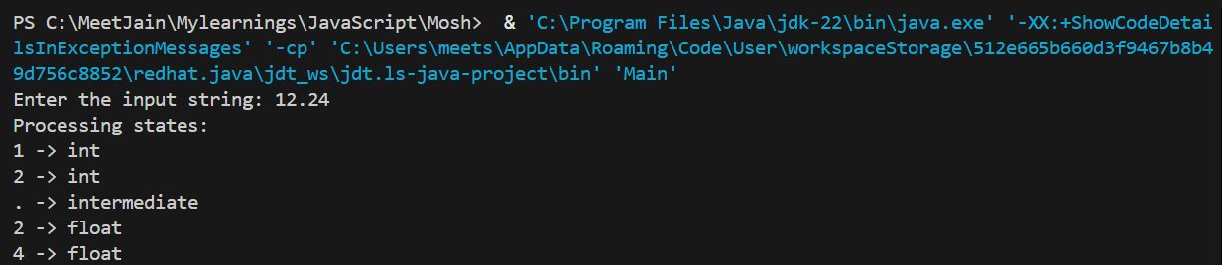

Class Diagram:

